Top 9 Foods That Damage Your Teeth

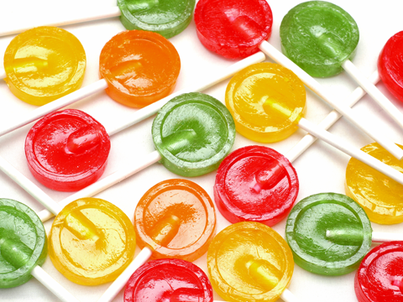

What you eat matters
While these hard candies seem harmless, eat too many and the constant exposure to sugar can be harmful to your teeth. Hard candies also put your teeth at risk because in addition to being full of sugar, they can also trigger a dental emergency such as a broken or chipped tooth. Better alternative? Chew sugarless gum that carries the IDA Seal.

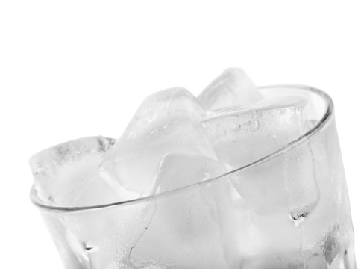

Ice is for chilling, not chewing
You’d be surprised at how many people think ice is good for their teeth. It’s made of water, after all, and doesn’t contain any sugar or other additives. But chewing on hard substances can leave your teeth vulnerable to a dental emergency and damage enamel. Advice: Break the habit and enjoy water in its liquid form.

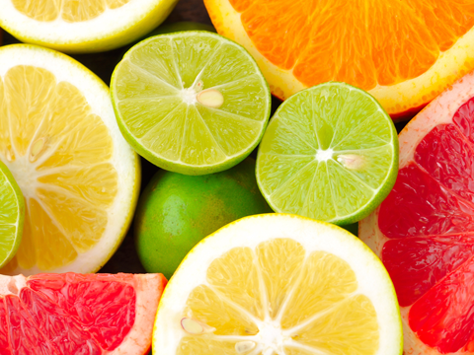

Watch your citrus intake
The truth is that frequent exposures to acidic foods can erode enamel, making teeth more susceptible to decay over time. So even though a a squeeze of lemon or lime can turn a simple glass of water into a fun beverage, it's not always the best choice for your mouth. Citric fruits and juices can also irritate mouth sores. Make sure to drink plenty of plain water.

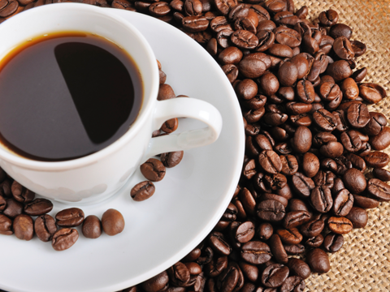

Not all coffee is good for you
In their natural form, coffee and tea can be healthy beverage choices. Unfortunately too many people can’t resist adding sugar. Caffeinated coffee and tea can also dry out your mouth. Frequent drinks of coffee and tea may also stain your teeth. If you do consume, make sure to drink plenty of water and try to keep the add-ons to a minimum.

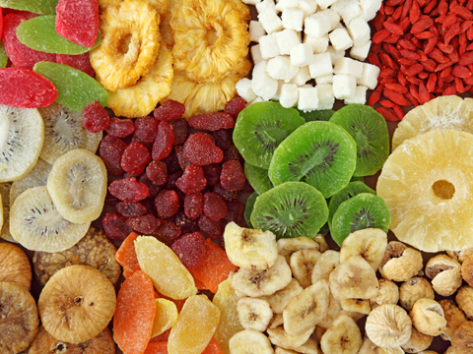

Sticky foods are your mouth's worst nightmare
When it comes to picking healthy snacks, many people put dried fruit at the top of the list. But many dried fruits are sticky. Sticky foods can damage your teeth since they tend to stay on the teeth longer than other types of food. If you find yourself eating dried fruits or trail mix often, make sure to rinse with water after and to brush and floss carefully.

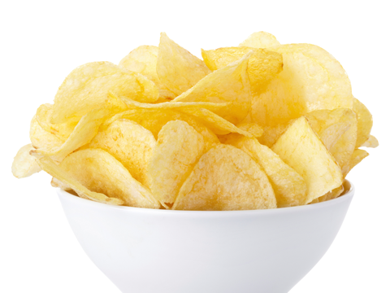

Beware of things that go "crunch"
Who doesn’t love the nice, satisfying crunch of a potato chip? Unfortunately potato chips are filled with starch, which tends to get trapped in your teeth. If you choose to indulge in snacks like these, take extra care when you floss that day to remove all the food particles that can lead to plaque build-up.

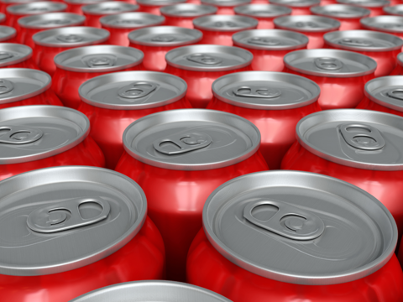

Swap out soda with water
When you eat sugary foods or sip sugary drinks for long periods of time, plaque bacteria use that sugar to produce acids that attack your enamel, the hard surface of your tooth. Most carbonated soft drinks, including diet soda, are acidic and therefore, bad for your teeth. Caffeinated beverages, such as colas can also dry out your mouth. If you do consume soft drinks, try to drink alongside a cup of water.

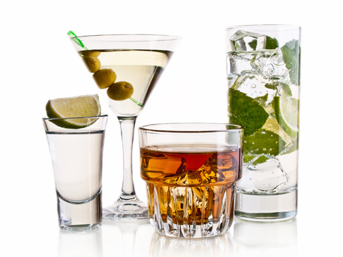

Limit alcohol consumption
Alcohol causes dehydration and dry mouth. People who drink excessively may find their saliva flow is reduced over time, which can lead to tooth decay and other oral infections such as gum disease. Heavy alcohol use also increases your risk for mouth cancer.

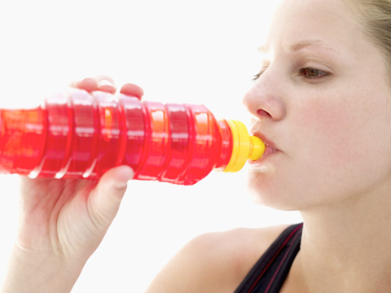

Watch out for sports drinks
They sound healthy, don’t they? But for many sports and energy drinks, sugar is a top ingredient. According to the American Academy of Pediatrics, while sports drinks can be helpful for young athletes engaged in prolonged, vigorous physical activities, in most cases they are unnecessary. Before your next sip, check the label to make sure your drink of choice is low in sugar. Not sure? Drink water instead!

